**Functionality and micro interactions**

Audience Needs

The main functionality of the site needs to be for the visitor to access basic pet care for different types of pets. The information needs to be easily accessible, if it is not obvious where to find information, then the user may decide it is too difficult to find and go elsewhere.

A responsive design is also important for the audience. This means that no matter what type of device is used to access the site, the layout should respond and still allow all the information to be viewed easily.

The site can include some micro-interactions to enhance the audience experience. These could include social media like and share buttons. This may increase the reach of the site through a ‘word-of-mouth’ type spread across the internet. There will also need to be a contact form to set up a consultation appointment with a ‘Pexpert’. The existing search function will remain, to help speed up the finding of information.

There is currently no need to add a vast number of micro-interactions as this may just detract from the ease of finding information, as there is limited new information on the site. However, in the future if more information is added there may be an argument for adding more micro-interactions such as horizontal scroll buttons or click/hover to reveal text and images.

Stakeholder Needs

If an audience user becomes a stakeholder, meaning they are now invested in using the site, a major feature and micro-interaction important to them would be the contact form to request a booking for a consultation appointment with a ‘Pexpert’. This form will need collect the user’s name, phone number, email, and time zone. These will all aid in the company being able to contact the user to arrange an appropriate time for a consultation. The form will also need to collect information on the pet, such as the pet’s name, type, and age. There should also be a text box to allow the user to enter any additional comments they may have. These will all allow the company to assign the appointment to a relevant ‘Pexpert’.

The other micro-interaction that would be useful for the stakeholder is the search function, as they may be looking for a specific piece of information and the search function should aid them finding it quickly.

**New page**

There will be a new page created for fish owners. This will have general information as the first section and then a section each for freshwater fish and saltwater fish. These two sections will contain some general information on keeping these types of fish along with specific water conditions required for each type of fish to ensure the visitors have the knowledge to perform water testing and maintenance. There will also be some images of each type of fish for visual impact.

**Existing content changes**

The site color scheme will be changed to fit in with the new branding of the company using the colors detailed in the Design Specifications. Similarly, the new company logo will replace the existing one on each page. These changes will allow for the pages to be more consistent throughout and keeps the company name in the user’s vision. The current site does not allow for this as it does not have the logo and company name together on each page. This aligns with the stakeholder’s request to have the page be easy to understand.

Currently, the Home page does not appear to be from a professional business, which could lead users to believe it does not include professional information. The text does not stand out and can even be overlooked due to it being overshadowed by the current pictures. The links to other pages also do not function correctly, if a user goes from the Home page to the FAQs page, they are unable to navigate back to the Home page without first going to either the Dogs or Cats page. This would make the user feel like the page is not reliable, which could lead them to believe the business is not reliable making them look elsewhere for their needs.

Giving the user a small example on the Home page of the information they will find on the other pages, keeps them wanting to see more. Removing most of the pictures and resizing the ones that are kept keeps the user engaged without overshadowing the information being displayed. Making sure all of the links work keeps up the user’s confidence in the site. These fall in line with the stakeholders needs for keeping the site easy to navigate and having the content be readable and easy to understand.

The FAQs link will be moved to the secondary navigation section as this section is likely to be used less than the other pages that will remain in the primary navigation section.

**New Site Map**

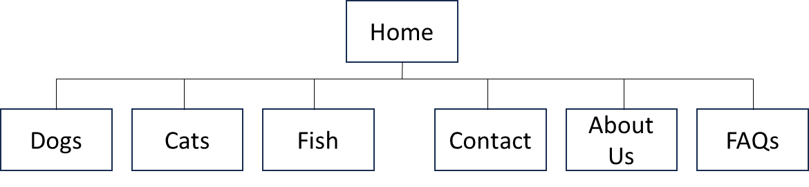

**Information Architecture**

The information architecture of the website will utilize the matrix style of navigation as users will want to access the pages that interest them and not need to be sent to pages in a particular order. The site will consist of a main navigation bar that will allow visitors to easily find the pet type that interests them, each of which will have its own page. There will another page that has information about the company. A contact form will be on a separate page to allow the visitor to request an appointment with a “Pexpert” with any additional questions regarding their pet.

There will be primary and secondary navigation elements to support the information architecture detailed above. The primary elements will include the landing or home page and one page for each pet type. These are primary as they will be the most used pages and will be located on the left-hand side of the navigation bar as traditionally this is where the eye is first drawn to. The secondary elements will be the company overview page, the FAQs page, search function and the form to request an appointment. These are all considered secondary elements as they will be used less frequently than the primary elements and will be located to the right-hand side of the navigation bar to give some separation from the primary elements.

The primary and secondary navigation elements will align with the stakeholder and audience needs by being easy to navigate, read and understand. They do this by being a contrasting color to the background and positioned at top of each page. There will be a visual identifier below the navigational element of the active page, this will enable the user to know immediately which page they are viewing in relation to the others.

**Landing page wireframe**

